Overview
The Issaquah Highlands Community has three community garden locations: Vista Gardens, Sunset Walk Gardens, and Westridge Gardens. The Community Gardens are managed by Highlands Council and the Issaquah Highlands Community Association.
Vista Gardens
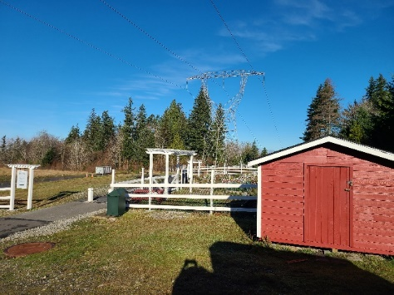
The Vista Gardens are located along the paved path between Park Drive at Trail Head Vista (across the street from Central Park) and Natalie Way. Follow the paved path, under the powerlines and look for the red shed – you have arrived!

The Vista garden area closest to the shed is Vista 1, and the fenced in area across the paved path from Vista 1 make up Vista 2.

The Vista gardens are the community’s first gardens, and a bit larger than the other gardens.
Sunset Walk Gardens
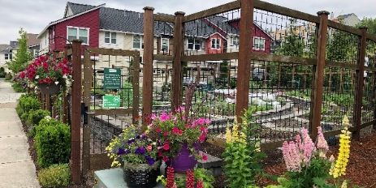
The Sunset Walk Gardens are in the Sunset Walk community, across Park Drive from Fire Station 73.

When you enter Sunset Walk on NE Hickory Lane, if you take an immediate left and then an immediate right, you will find Sunset Walk 1. Or by taking an immediate right upon entering the neighborhood you will find Sunset Walk 2 at the end of this residential street.

The Sunset Walk patches are in raised, concrete beds, and are a bit smaller than the Vista patches.

Westridge Garden
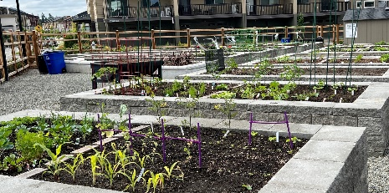
The Westridge Community Garden is located at the corner of Westridge SE and 6th Ave NE.
The Westridge patches are in raised, concrete beds, are a bit smaller than the Vista patches and include two accessible ADA plots.

Garden Use
Our Community Garden provides a chance to get to know some of your Issaquah Highlands (“IH”) neighbors, to have fun, to share the workload and to enjoy all the fresh produce. Please be considerate so that everyone can benefit from their time in the garden.

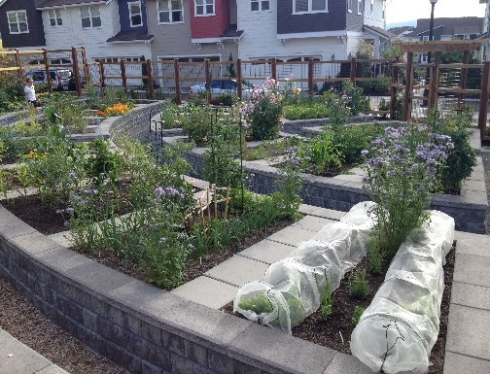
- Share. It is a community garden.
- The garden is open from dawn to dusk.
- Always keep the gates closed.
- Resolve differences in a neighborly way.
- Be considerate. If you bring a radio to the garden, use headphones.
- Pets are not allowed in the garden. This includes dogs on leash.
- Please supervise your children closely. Encourage and model respectful behavior toward neighbors and their garden patches.
- No alcohol or illegal substances may be brought onto or consumed on the entire site. The sole exception to this is that slug bait containing beer can be used in enclosed containers within a patch.
- Tobacco use, e-cigarette use, and vaping are prohibited in the garden.
- The use of chemically treated wood is prohibited within the garden. These products contain toxic substances which may leach into the soil. Tires are not allowed at the site.
- Please pick up any trash and dispose of it in the trash receptacle provided.
- Always clean tools after using them and return them clean and dry to the shed (Vista and Westridge Gardens) or hooks (Sunset Walk).

- Tools may not be removed from the garden area for any reason whatsoever. Please report broken or missing tools at https://www.issaquahhighlands.com/community-garden/gardeners/.

REPORT CONCERNS
Report bad behavior, graffiti, or maintenance concerns ASAP at https://www.issaquahhighlands.com/community-garden/gardeners/.

CONTACT
Michele McFarland at michele.m@ihcouncil.org or 425-507-1108

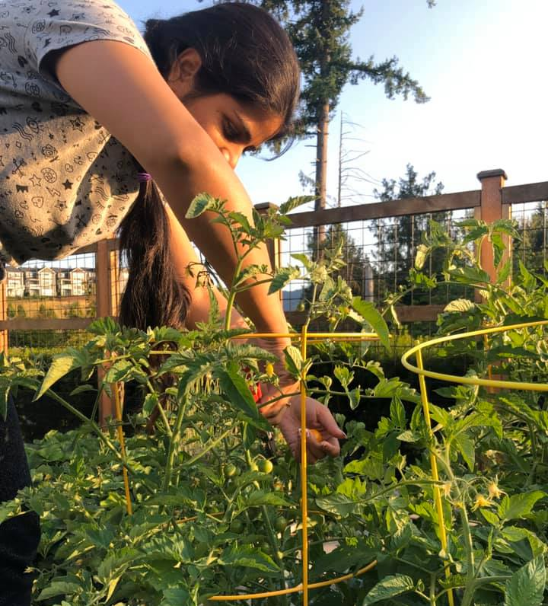
Patch Use & Maintenance

- Maintaining your garden is your responsibility. If you do not maintain and harvest your patch, it may be reassigned, and your fees forfeited. Your patch will be reassigned if it is not worked by June 1. Exceptions may be made for special circumstances with prior approval. Patches not rented by June 1 will be maintained by IH staff until rented.
- Your $25 deposit will be forfeited if you abandon your patch.
- Plants that can harbor pests or disease (such as tomato plants) should be removed as soon as they stop producing.
- If you are going to be out of town during the growing season, please ensure your patch is maintained in your absence. It is your responsibility to find someone to water, harvest and weed as needed. If you have a non- community gardener assisting in your absence, it is your responsibility to make sure they are familiar with the boundaries of your patch and comply with the rules and regulations.
- Keep vining and spreading crops confined to your own patch, or preferably confined to pots within your patch. Pots outside your patch are NOT allowed.
- Perennial crops can be problematic for the next gardener. Carefully consider your long-term plans before you plant strawberries, herbs, bulbs, artichokes, etc. If you plant perennials and decide to not renew your patch you must remove the perennials at the end of your rental period.
- Raspberries may NOT be planted as they are invasive.
- Please be careful that sunflowers or tall trellised plants do not shade your neighbor’s patch. Trees and permanent structures are not allowed.
- Do not dig into the common paths. Keep them level, plant free, uncluttered and open at all times for walking and maintenance. Do not block or barricade off the paths.

Harvesting Crops
- As crops mature, keep them harvested at least weekly. This helps prevent disease and keeps wildlife away.

- Sharing produce is encouraged, but it may not be sold. If you wish to share your produce, please pick and give it away yourself. Don’t invite non-community garden members to come and pick when you are not at the garden. Misunderstandings can occur about patch boundaries and where picking is allowed.

- You are encouraged to donate 10% of your produce to the Issaquah Food Bank.

Insecticides, Herbicides & Soil |  | Water Responsibly
- The community garden is for organic gardening only.  - The use of fertilizers, insecticides and herbicides made from synthetic chemical materials is prohibited.  - Some organic pesticides are permitted in the garden, such as rotenone, pyrethrin and insecticidal soap. Read and follow label instructions. Misuse of pesticides may result in forfeiture of gardening privileges.  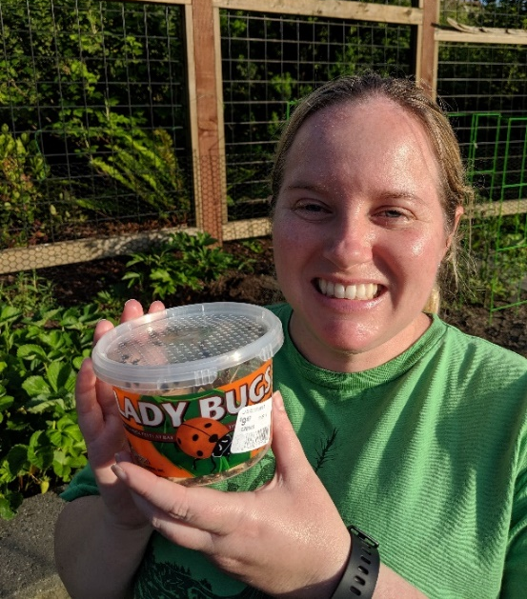  - Any pesticide application must be kept within the confines of the single rented garden patch. Keep all pesticides out of children’s reach and remove them from the garden daily. Never store pesticides or fertilizer in the direct sun or in the garden areas. Pesticides may not be stored in the Vista tool shed.  - Slug bait based on iron phosphate (e.g. Sluggo) is allowed. Copper tape is not allowed.  - Blood and livestock-based bone meals are currently NOT allowed as soil amendments. Fish and poultry-based products are acceptable. |  | 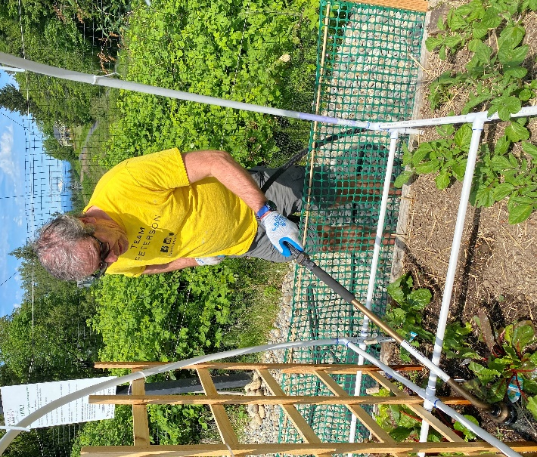  - Remember that water is a precious and expensive commodity that is paid for by your patch fees. Please water responsibly.  - Gardeners are responsible for maintaining and watering their own patches. Please treat hoses and water wands or nozzles carefully and return them when finished.  - Be sure to turn the water off AT THE HYDRANT VALVE when you are finished. The valve on the wand or nozzle is not a shutoff.  - Unattended watering is not permitted. Please be careful to water only within your patch.  - When moving hoses, please make sure you do not damage others’ plants, drag them through others’ patches or drag them across sharp stones.  - Water service is turned off and the pipes drained for winter between October and April.
Composting
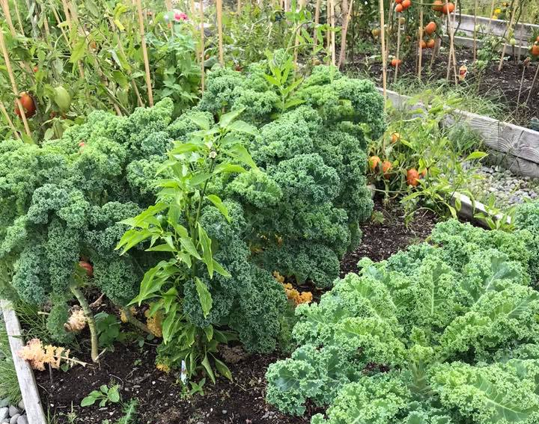
Community compost bins are provided for organic garden waste only. Please do not put trash in the compost bins. Use the trash bin or take it home with you to dispose of it.

- Diseased and pest-ridden plants must be removed from the site by the gardener.

Garden Sheds
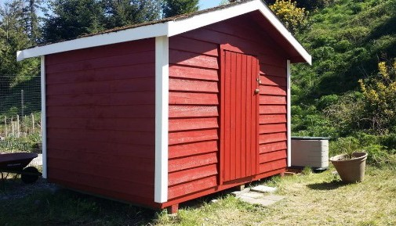
- The tools/supplies located in the garden sheds at Vista and Westridge are for use by all gardeners in those locations.

- The tool sheds should remain locked at all times to prevent theft/vandalism.

- The combinations to the locks on the sheds will be provided to Vista and Westridge Gardeners via e-mail at the beginning of the growing season. Please do not share with anyone who does not have a leased patch in the garden.

Additional Vista Garden Rules
HIGH POWER LINE HAZARD
In the Vista Gardens, metal tomato cages, wires, stakes (even when rubber- coated), trellises and other metal structures including decorative ones are NOT allowed. The high voltage wires above the gardens might arc to metal structures and cause injury or worse.
This is a condition of our special use permit with the Bonneville Power Authority and violations will not be tolerated. Bamboo, untreated cedar and PVC pipe can be used for staking and trellis structures; plastic netting or twine can be used on trellis.

- Any metal used in the garden is subject to immediate removal and disposal by staff. Any removed items will not be returned to the gardener.

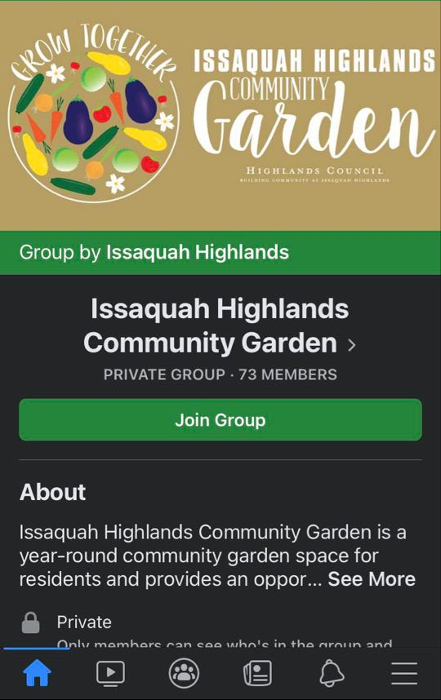
Connections & Getting Involved
Facebook Group
Connect with fellow IH Community Gardeners on Facebook! The group is limited to current community gardeners. Visit www.facebook.com/groups/ihgardens (or search for “Issaquah Highlands Community Garden” on Facebook) to join and connect.

Garden Ambassador Program
Would you like to be more involved in the operations of the garden? Help plan social events? Assist your fellow gardeners throughout the season?

Garden Ambassadors are important members of our Community Garden program. Responsibilities include:
- Regularly visiting the garden and reporting back any maintenance issues or areas of concern.
- Recommending long term/strategic updates for the garden.
- Being available as a contact point to support fellow gardeners, especially new gardeners, with questions and issues. This may include answering questions and staying engaged in the Community Garden Facebook group.
- Writing gardening articles to be published in Connections and on the IH blog.
- Helping plan social gatherings or opportunities for gardeners to connect.

If you’re interested in being a Garden Ambassador for 2024, please contact Michele at michele.m@ihcouncil.org or check the box on your Garden Patch Application Form.

