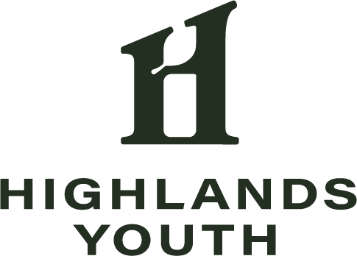
Highlands Youth Advisory Board
Established in 2013, the Highlands Youth (HY) Advisory Board was created to advise on the community building efforts of Highlands Council, providing youth a voice in community matters. The mission of the HY Board is to unify Issaquah Highlands youth through meaningful and fun social experiences, creating lasting memories and building pride in our community. The HY Board's past events include the Middle School Halloween Party, Flashlight Egg Hunt, and End of School Year Night at the Carnival. Past service projects of the HY include building eight of our ten Little Free Libraries, Parents Night Out events, Treats & Tails and multiple community art projects. HY Board members may also participate in Highlands Council Board of Trustee meetings, and as members of Highlands Council committees such as branding, transportation and cross-cultural.

2024-25 Highlands Youth Advisory Board Application

Note: Applications must be submitted online BY APRIL 30.
This document is to aid in preparing your answers and is not required.

- Name (First & Last)
- Street Address
- Email Address
- Cell Phone Number (if you have one)
- What is your birth date?
- In what grade will you be in Fall 2024?
- Where will you attend school in Fall 2024? (Name of school)
- Please provide the name of a parent/guardian
- Parent/Guardian Email Address
- Parent/Guardian Cell Phone Number

Q6. How have you been involved in the Issaquah Highlands community?

Q7. Which of the following events have you attended? (Select all that apply)

- Middle School Halloween Party
- Middle School Egg Hunt
- Global Grub & Groove
- Superbowl Party
- LEGO Expo
- Veterans Day
- Open Mic Night
- Village Market
- Other (please specify)
- None of the above

Q8. How do you spend your time when you’re not in school? (sports, extracurricular activities, friends, etc.)

Q9. Which of your leadership traits are you most proud of, and why?

Q10. What interests you about joining the HY Board?

REQUIREMENTS

The HY Board plans awesome events, but that’s not all we do. As leaders of our youth community, members of the HY Board are expected to be present in the community, fostering connections, and setting an example for all youth.

The mandatory attendance dates for the 2024-25 HY Board Year (specific dates are subject to change) are listed below. Please check with your family before agreeing to the dates – once you submit this application, we will expect you to be there.

- Attend team building on June 2, 5-7 p.m. (dinner included)

- Participate in regular Sunday meetings on:

Sept. 22. 2-4 p.m.
Oct. 6, 2-4 p.m.
Nov. 10, 2-4 p.m.
Jan. 12, 2-4 p.m.
Feb. 9, 12-2 p.m.
March 2, 2-4 p.m.
March 23, 2-4 p.m.
April 27, 2-4 p.m.

- Participate in all HY Board planned events (set up, clean up, and working the event), including:
Middle School Halloween Party – Fri., Oct. 25 (4-10 p.m.)
Parent’s Night Out – Fri., Dec. 13 (4-10 p.m.)
Flashlight Egg Hunt – Fri., April 4 (4-10 p.m.)

In addition, HY Board members are expected to:

- Volunteer for additional opportunities – the majority are in Issaquah Highlands and are offered throughout the year. HY Board members are expected to volunteer a MINIMUM of 15 additional hours throughout the year. (For reference, this year we offered over 80 hours of additional volunteer options).

- Write at least one article for our community media.
Q10. If selected, will you be able to honor the commitments required to serve on the HY Board (listed above)?

- Yes
- I might have an issue (please explain)

Q12. Anything else you’d like to share?

